



**Project Name**

***Android Based E-Voting System***

**By**

**Muhammad Nadeem CIIT/FA20-BSE-035 Muhammad Usman CIIT/FA20-BSE-055**

***Supervisor* Supervisor Name Sir Nashit Ali**

***Bachelor of Science in Computer Science (2020-2024)***

**COMSATS University Islamabad Islamabad, Pakistan**

**Project Name**

***Android Based E-Voting System***

**By**

**Muhammad Nadeem CIIT/FA20-BSE-035**

**Muhammad Usman CIIT/FA20-BSE-055**

***Supervisor* Supervisor Name Sir Nashit Ali**

**Bachelor of Science in Computer Science (2020-2024)**

**The candidate confirms that the work submitted is their own and appropriate credit has been given where reference has been made to the work of others.**

**Declaration**

We hereby declare that this software, neither whole nor as a part has been copied out from any source. It is further declared that we have developed this software and accompanied report entirely on the basis of our personal efforts. If any part of this project is proved to be copied out from any source or found to be reproduction of some other. We will stand by the consequences. No Portion of the work presented has been submitted of any application for any other degree or qualification of this or any other university or institute of learning.

Student Name 1 Student Name 2



**Certificate of Approval**

It is to certify that the final year project of BS (SE) “Android Based E-Voting System” was developed by **Muhammad Nadeem (CIIT/FA20-BSE-035)** and **Muhammad Usman (CIIT/FA20-BSE-055)** under the supervision of “Sir Nashit Ali” and that in his opinion; it is fully adequate, in scope and quality for the degree of Bachelors of Science in Computer Sciences.



**Supervisor**



**External Examiner**



**Head of Department**

**(Department of Computer Science)**

**Executive Summary**

The Android-based e-voting system is a secure and efficient way to cast votes electronically. It uses Android devices to enable voters to select candidates or options easily.

The system ensures the integrity and secrecy of votes through end-to-end encryption and secure authentication.

Votes are stored and counted electronically, reducing the risk of human error.

The system provides real-time results and can increase voter turnout, especially among remote or disabled voters.

**Acknowledgement**

All praise is to Almighty Allah who bestowed upon us a minute portion of His boundless knowledge by virtue of which we were able to accomplish this challenging task.

We are greatly indebted to our project supervisor “Sir Nashit Ali”. Without his personal supervision, advice and valuable guidance, completion of this project would have been doubtful. We are deeply indebted to him for their encouragement and continual help during this work.

And we are also thankful to our parents and family who have been a constant source of encouragement for us and brought us the values of honesty & hard work.

Student Name 1 Student Name 2



**Abbreviations**

| **SRS** | Software Require Specification |
| --- | --- |
| **PC** | Personal Computer |
| **APIs** | Application Programming Interfaces |
| **PKI** | Public Key Infrastructure |
|  |  |

**Table of Contents**

1. **INTRODUCTION** **4**
   1. System Introduction 4
   2. Background of the System 4
   3. Objectives of the System 4
   4. Significance of the System 5
2. **REQUIREMENT SPECIFICATIONS** **6**
   1. Product Scope 6
   2. Product Description 6
      1. Product Perspective 6
      2. Product Functionality 6
      3. Users and Characteristics 7
      4. Operating Environment 8
   3. Specific Requirements 8
      1. Functional Requirements 8
      2. Behavioral Requirements 10
      3. External Interface Requirements 12
      4. Other Interfaces (if any) 23
   4. Non-functional Requirements 25
      1. Performance Requirements 25
      2. Safety and Security Requirements 26
      3. Software Quality Attributes 26
3. **DESIGN SPECIFICATIONS** **28**
   1. Explanation 28
   2. Composite Viewpoint 29
   3. Logical Viewpoint 30
   4. Information Viewpoint 31
   5. Interaction Viewpoint 32
   6. State Dynamics Viewpoint 32
   7. Algorithmic Viewpoint 32

3.6 State Dynamics Viewpoint 34

1. **DEVELOPMENT AND TOOLS** **36**
   1. Define 36
   2. Development Plan 36
   3. Development Tools 37
   4. Conclusion and Future Work/Extensions 37
2. **QUALITY ASSURANCE** **38**
   1. Define 38
   2. Traceability Matrix 38
   3. Test Plan 40
3. **USER MANUAL** **42**
   1. Introduction 42
   2. Hardware/Software Requirements for the System 42
   3. Installation guide for Application 42
   4. Operating Manual 4

# INTRODUCTION

Thus, the arrival of this period has given a warm welcome to the concept of voting. We are soon going to transform the way people do elections, with our Android solution which involves a mobile application to ease the process. That way, through the application of real face and fingerprint identification, we are ensured that only actual votes are being cast hence secure voting. The main goal of this application is to enhance the turnout results of a voter by offering convenience in addition to live results. Also, it also makes it possible for users to confirm their votes and in doing so it also promotes the issue of transparency and accountability.

## System Introduction

This concept which is still nascent but relies on the Android platform is all about changing the way people vote by making the process easy, secure virtually via a voting application. Apparently, the idea of a system where people can vote through surveys with the choice selected via facial recognition supported by fingerprint verification for security consideratioons where the users can vote is what our system aims to be. As a result there is need for people to take part in elections and therefore the desire for convenience plus immediate feedback has been ushered in by these features on an app. Just as acceptable, the openness that arises when individuals are able to validate both the vote and the election of the vote’s representative also requires accountability.

## Background of the System

Here, this project is concerned with an android-based e-voting solution to the problems encountered during the conventional manual paper-base voting. Some of these include; user-friendliness, security and accessibility among others all incorporated in the development of this type of application. This helps in making sure that even before one gets to figure out what it is that happens when they use such a corresponding application like the one we are developing; they do not have to waste a lot of time wondering whether it would be safe or convenient to use the app since it has all been handled on their behalf. For instance, there is the introduction of face identification recognition which keeps things much more secured than, say, using the typical password alone thus making them very dependable as well.

## Objectives of the System

* The objectives of the Android-based e-voting system are as follows:The objectives of the Android-based e-voting system are as follows:
* To ensure people vote without obstacles by creating an application for the voters to vote from their mobile devices effortlessly.
* To improve the authenticity of the vote by using both credit card and encryption.
* To make the results immediate and delegate the analysis for the election administrators.
* Because of the high volume of voters and the timelines when the voting is conducted and when the results are expected to be released, it also has the following objectives To minimize on the costs of having to deal with paper ballots and manual voting and count McGrath (2013).
* To make voting easy for disabled persons while at the same time creating other design features to cater for the increasing number of voters.
* For accommodating a general multiple tiers of elections such as political, academic, corporate among others.

## Significance of the System

**Accessibility and Convenience:**

One major advantage of E-voting is that it enables the citizens to vote from wherever they are in the country by eliminating the physical space or limited movements. Which in turn increases voter turnout and participation, thanks to the accessibility of the Web environment.

**Efficiency and Speed:**

Helps in fast and efficient voting since the results will be obtained once the button is pressed or a switch is turned. From where it eliminates time wastage and uncertainty which can be occasioned by manual counting of votes and leads to quicker declaration of election results.

**Reduced Errors and Fraud:**

The other advantage of E-voting system is that it has incorporated methods of checking and tallying votes and therefore it eliminates cases of fraud or errors that may be attributed to manually written ballots.

**Enhanced Transparency:**

Some e-voting systems offer greater transparency by allowing voters to verify their votes and ensuring that votes are recorded accurately. Block chain technology, for instance, can enable a transparent and immutable record of votes.

**Cost Efficiency:**

Some systems have extra functionality in terms of transparency since the voter may be able to check and confirm his/her vote and that the vote cast has been recorded properly. Example of relevant technological advancement is, for instance, block chain technology can make voting to be transparent and verifiable.

**Environmental Impact:**

Transitioning from using paper-based voting to reaching for electronic system positive environmental effects can be drawn from the reduced use of paper and therefore less wastage.

# REQUIREMENT SPECIFICATIONS

The Android-based e-voting system has been developed using Flutter, and its next critical component is the verification of users. In order to achieve this, it should provide safe-sign up procedures like email/password, face detection or fingerprint scan. It should be easy to use for casting votes and must be able to present clear information about candidates or issues and allow vote casting with minimum hitches. Safeguarding the users data and the integrity of the votes cast needs special protection which can be through the use of encryption methods and biometric identification.

## Product Scope

The Android e-voting system developed with Flutter requires the identification of areas important to voter registration that can be optimized for smooth and secure voter registration. On this matter, it should employ measures such as encryption and multi-factor authorization to cover it against hacking. The platform should be accessible on any browsing device, and the use of biometrics means only qualified voters can vote securely. The system should ensure it recorded all the votes and also ensure that the process was well documented for refereeing purposes. It should also be easily navigable and usable to the disabled. This is an important factor since there may be times when there are a lot of voters and it is important to follow the laws governing elections and other related laws like data privacy and protection, and updates on the status of the system’s maintenance and support.

## Product Description

### Product Perspective

It should be compatible with the existing election tools like voter databases as well as result calculators to ensure that it has strong safety measures like encrypting votes themselves among other ways to ensure anonymity the entire process without compromising simplicity for all including those with impairments besides being able to handle many simultaneous connections without stalling at any one time and all rules pertaining to conduct during an election period to protect personal data as per the regular updates offered together with technical support needed.

### Product Functionality

**Voter Authentication:** Systems typically require secure login procedures to authenticate eligible voters, often using unique identifiers like voter IDs, passwords, or biometric data. **Ballot Casting:** Users can securely cast their votes electronically through an intuitive interface, choosing candidates or options based on the election type.

**Ballot Verification:** Voters may have the option to review and verify their choices before submitting their ballots to ensure accuracy.

**Security Measures:**

Encryption and firewalls secure the ordered documents from any unauthorized access, modifications, or attempts by hackers. Often systems are designed to produce extensive audit trails so that all the activities with in that system are absolutely transparent with regard to accountability.

**Audit Trail:**

Tabulating systems handle the tallying of the votes in an automated way, reducing chances of making wrong tallies, and then they are fast in producing the results.

**Tabulation and Tallying**:

E-voting systems should be able to address these needs of the users; for the handicapped or the linguistically challenged, they should have provisions for; accessible means to vote.

**Accessibility Features:**

There should be accommodation of various user types in e-voting systems and facilities for disabled voters or those whose first language is not the national language.

**Scalability and Reliability**:

It should be able to work for the large-scale election perfectly and the issues of a large number of traffic and users should not affect its stability.

**Anonymity and Privacy:**

Systems have to preserve the votes and the identity of the voters, and also have to follow rules regarding the privacy of the voters.

**User Support and Training:**

User support, training documents and help, where voters and administrators can be given appropriate aid to utilise the system effectively.

**Testing and Certification:**

It has to be tested and certified to ensure that it is secure and functions properly before being used for an election.

* + 1. **Features of E-Voting Systems:**

**Accessibility:**

In this way, people with different disabilities can cast their votes from home or mobile devices for instance.

**Security:**

Have stringent security arrangements that ensure there is no interference of the election process by anyone as well as the assurance that votes are recorded accurately and kept confidential.

**Accuracy:**

Make sure all votes are counted without any mistakes during tallying of results later on.

**Transparency:**

Allow stakeholders to examine this process in order to verify its equity and legitimacy.

**Auditability:**

Enable those who wish to see whether or not things were done rightly to follow every step in a voting procedure until everything is successfully completed thereby guaranteeing accountability throughout.

**Usability:**

Create user-friendly interfaces for easy usage

**Scalability:**

Handling numerous votes without compromising performance and security

**Resilience:**

Withstanding technological glitches or assaults while upholding the electoral integrity.

### Operating Environment

**Security Measures:**

The system should have strong security measures in force to avert any hacking, trespassing or unauthorized access. This may include encryption, multi-factor authentication and regular security audit among others.

**Reliability and Stability:**

The functioning of the system must be uninterrupted; it has to work reliably without breaking down. To achieve this, reliable hardware, software and network infrastructure are needed.

**Accessibility:**

Therefore, the system should be user-friendly for all qualified voters despite their physical limitations so that they can use it. Moreover, it should be able to support various devices and provide many different languages.

**Scalability:**

In case of peak times when there are different numbers of users on board the platform, the system is supposed to perform well as ever. It must possess enough capacity to scale up with numerous users.

**Transparency and Auditability:**

In order to ensure accuracy and fairness votes can be audited throughout. Besides this, a verifiable record like paper trail should also be availed for purposes such as these.

**Regulatory Compliance:**

For instance, all applicable laws, regulations or standards relating with elections or data protection shall have been adhered to by this system.

**Backup and Recovery:**

This will enable saving of data when systems fail hence there is need for proper backup system in place during failure of systems.

## Specific Requirements

* + 1. **Functional**

**Requirements**

**Administrator module:**

Another function in the admin login through facial recognition authentication, adding voters data.

Candidate information erasing/modifying, Construction of a poll/election ,

The services consist of: The provision of database containing the details of voters, Alteration/deletion of voter details contained in the database, provision of the database that would contain the overall figure of cast votes.

Representing total casted votes and voting ratio etc. graphically Reporting/the graphical representation of the total casted votes and voting ratio selectively, Preparing a detailed report based on demography, sex differences etc. such as male/female voting ratio.

**Voter Module:**

Integration of the system with Android application to get access.

Registering to vote or electronically vote using facial recognition authentication, To cast a vote in favor of the preferred candidate/subject

**Voting Module:**

Election judgments after polling time has been closed.

Overall-casted votes and overall-voting ratio.

Other publishing results Reporting based on Demographics, Male/Female Voting Ratio among others.

**Real-time Updates:**

* This would entail providing live information about the election proceedings such as the number of votes cast up to now, provisional results and so on.

**Data Backup and Recovery:**

* Regularly backing up voting data and implementing reliable data recovery mechanism in case of system failure.

### Behavioral Requirements

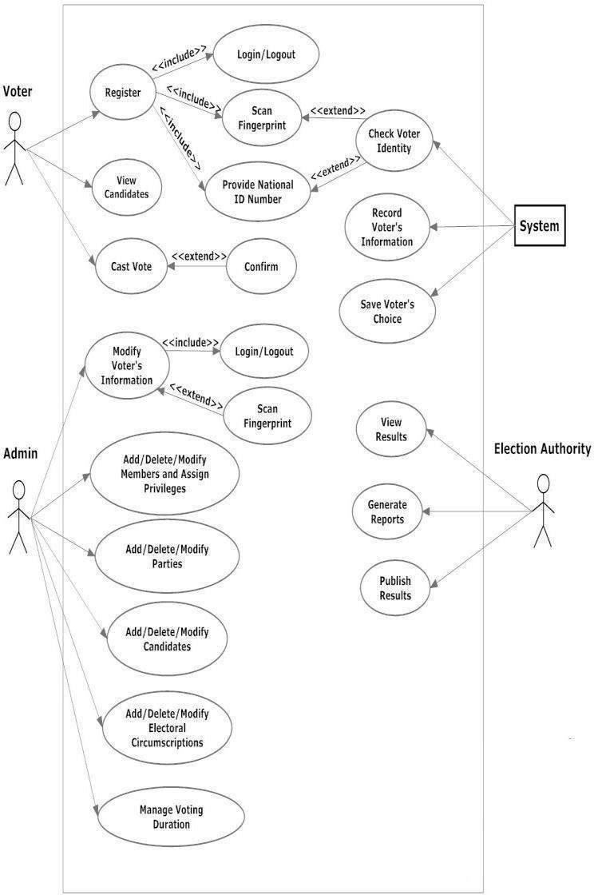

#### Figure 1: Use Case Diagram

**User Verification and Authorization:**

The method must ensure that it verifies people in the right way which is letting only registered voters.

**Monitoring & Reporting in Real-Time:**

For instance, officials should be equipped with gadgets that monitor the number of people voting among other related activities.

Generate detailed reports on results achieved after finishing voting process.

**Feedback and Support for Users:**

This system shall provide users with a platform to report any issue concerning the system and give their opinion as well.

Create quick responsive support systems to address user questions as well as technical challenges.

### External Interface Requirements

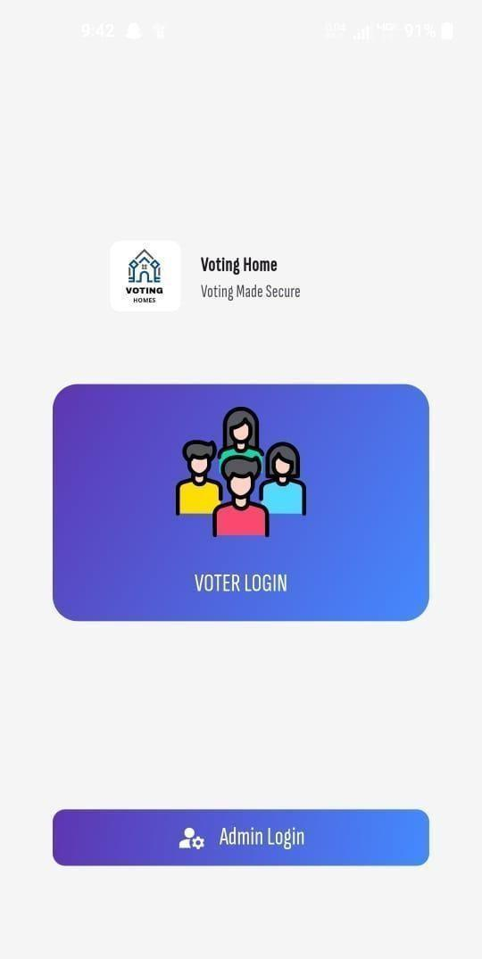

*Figure 2: Home Page*

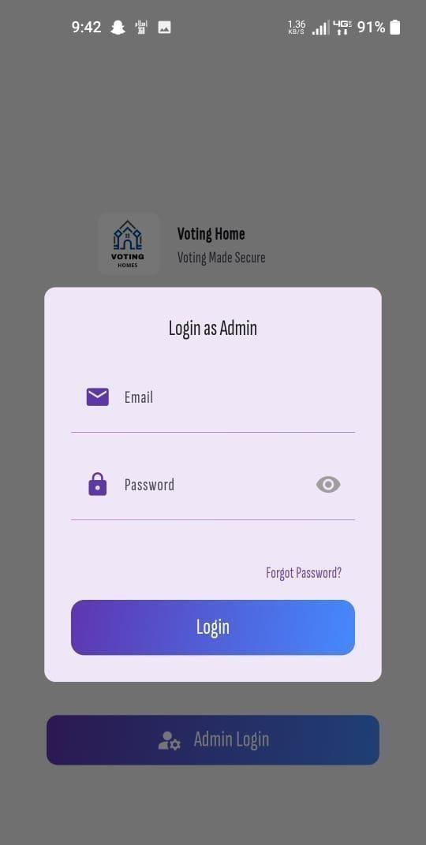

*Figure 3: Admin Login Page*



*Figure 4: Admin Dashboard*

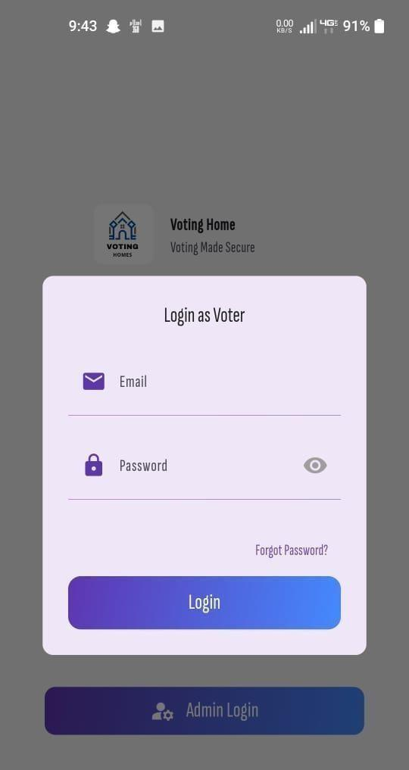

*Figure 5: Voter Login Page*

**

*Figure 6: Admin Registration*

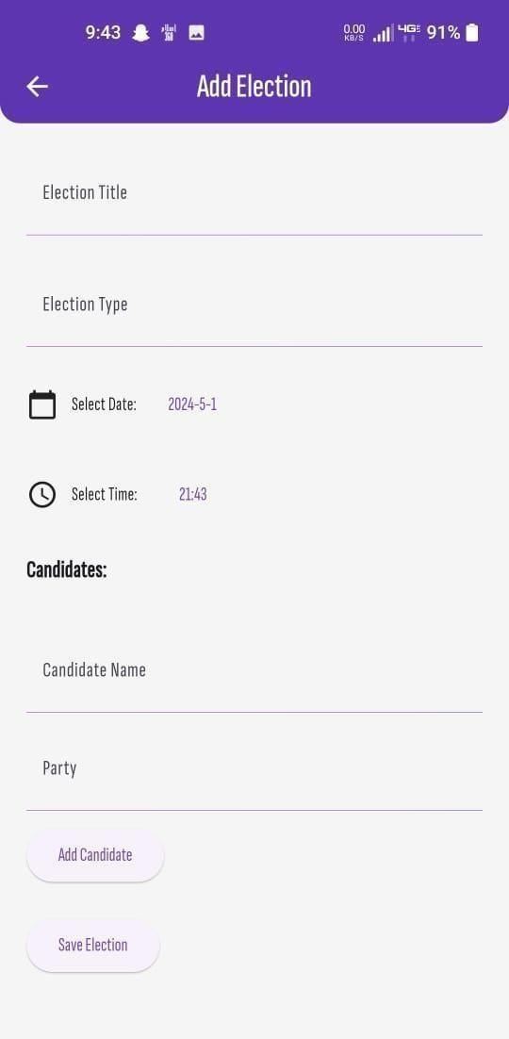

*Figure 7: Add Election*



*Figure 8: Register User*



*Figure 9: Upcoming Election*



*Figure 10: Election Details*

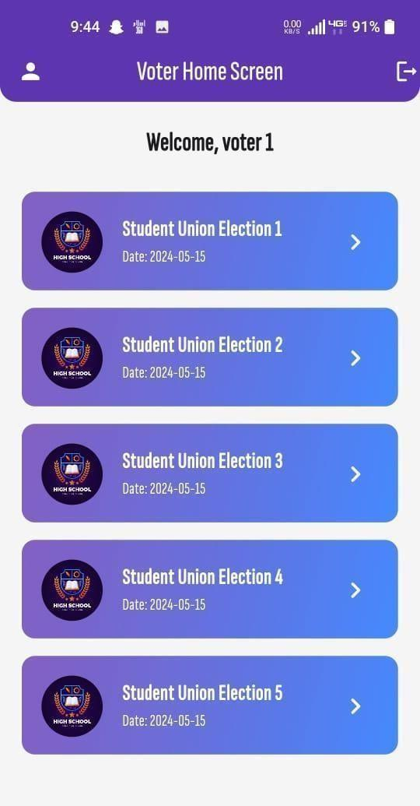

*Figure 11: Voter Home Screen*

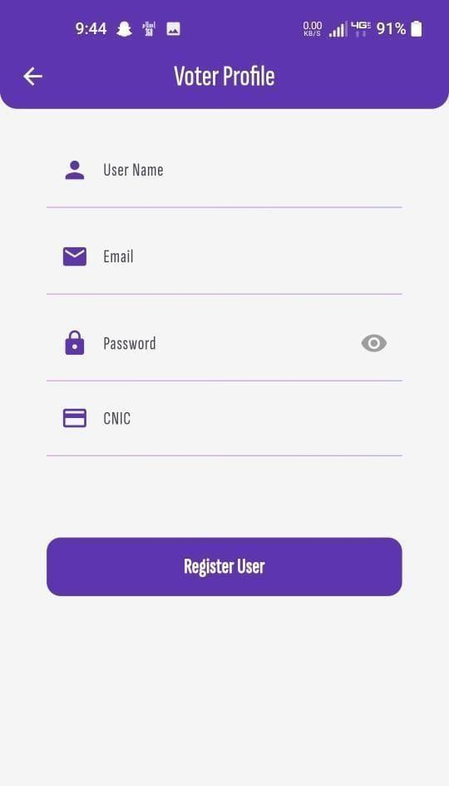

*Figure 12: Voter Profile*

#### User Interface

**Voter registration interface:**

The system should be integrated with a secure voter registration database that certifies the authenticity and accuracy of the voter information provided during registration.

**Biometric verification systems:**

This must be able to interoperate with biometric authentication systems which may include fingerprint or retina scans for further verification of voter identities.

**Government identity databases:**

These must connect to government identification databases like national identity systems in order to check if voters are eligible.

* + 1. **Other Interfaces (if any) Hardware Interfaces:**

**Voting Machines or Devices:**

Discuss the hardware requirements and standards that will influence the manufacture of voting machines or devices for use by electorates during electronic voting.

**Smart Cards or Tokens:**

Indicate compatibility specifications to enable e-voting software to operate efficiently with specific hardware.

**Network Infrastructure:**

Specify servers needed; routers; switches etc plus other network equipment necessary for supporting e-votes through efficient network infrastructure.

**Software Interfaces:**

**Voter Registration System:**

* Schedule meetings with the voter registration databases for the purpose of input validation and data confirmation when registering voters.
* Make clear how, for example, one system will be able to send information to another and in what format the data will be in.

**Biometric Verification Software:**

* I identify with software that is used in biometric verification for the purpose of identification.
* Stipulate how biometric data exchange between users should be conducted is secure.

**Election Commission Database:**

* Connect to the election commission’s database through software interfaces to retrieve official candidate lists, details of the electoral districts for configuring ballots, and other pertinent data.
* State the formats for data exchange and the frequency with which these exchanges will happen.

**External Authentication Services:**

* Extend loading of user credentials from external identity providers such as multi-factor authentication providers to boost security of user login and access.
* Establish the means of exchanging information that regulate and secure authentication processes.

**Notification Services:**

* Communicate with popular notification means such as e-mail or SMS to inform the voters registered with the service on the forthcoming elections, voting sites and various other details.
* Identify and define the formats of messaging and methods of delivery.

**Security Software:**

* Integrate with layers of visual security programs to have an active view of the threats and avoid intrusions.
* Establish standards as to the exchange of information pertinent to security threats as they occur.

**Mobile App Interfaces (if applicable):**

* If the e-voting system will have a mobile application, then, provide further details on how the mobile application will interact with the main system by defining software interfaces.
* Determine how data is shared with other systems and applications and using which data exchange formats and synchronization methods.

**Communication Interfaces:**

**Network Protocols:**

* Explicitly indicate the specific protocols of data transmission, such as TCP/IP, HTTP, or others that are safe to use for communication within the components of the e-voting system.

**Web Services/APIs:**

* Specify web services or APIs to ease interaction between modules of the e-voting system so that it would be compatible..

**Encryption Standards:**

* Define encryption protocols (for example, Security Sockets Layer/Transport Layer Security) that would protect exchange of information between the clients (voters), the servers, as well as the other components of the succeeding systems in order to maintain the confidentiality and the integrity of the information.

**Message Queues (if applicable):**

* If the communication between the components is asynchronous via the means of message queuing then it is required to state the message queuing protocols and standards being used in the system.

**Wireless Communication (if applicable):**

* Provide guidelines for the use of wireless technologies if the e-voting system includes that is supporting mobile voting or any part of it.

**Data Formats:**

* Prescribe the common formats of the data exchange, such as JSON, XML between the components in the systems to facilitate consistency in data sharing.

**Push Notifications (if applicable):**

* In case of supporting the push notification to the voters, describe the parameters and standards to secure the notifications to be pushed..

**Public Key Infrastructure (PKI):**

* Explain how the above system will incorporate PKI to oversee the management of keys as well as secure messaging with the use of digital signatures and encryption to enhance the validity and purity of the information.

## Non-functional Requirements

* + 1. **Performance**

**Requirements Scalability:**

* In the context of the elections, this system has to be adjusted to an increase or a decrease in the number of users at some point or other.
* It also need to have scalability because it can easily manage high amount of visitors at time of voting without freezing.

**Response Time:**

* For those candidates who are using the system, they should not be made to wait hence the response time should be minimal.
* The options of the software algorithms and the networks must be designed in a way that allows for the fast processing of the votes and the ability to update immediately.

**Concurrency Handling:**

* At the same time, someone has to be able to update data in it and it has to work even if many users are accessing it at the same time thus incorporate methods for multiple user access.

**Reliability and Availability:**

* Some of these aspects are basic guidelines which are as follows: A load balancing and actual failover mechanisms, coupled with redundancy aspects should be incorporated into the design in order to improve the reliability.
* When it comes to election this is a very important aspect to consider in that during critical phases of election the service cannot fail easily hence ensuring that there is high availability across all the components that are involved in service delivery.

**Data Transfer Efficiency:**

* Improve data transfer rate on client computers or devices over a network which will help to lessen workload on those networks hence boosting efficiency through out the overall enhancement of the whole network performance.
* In the same way, the format of exchanging data can also be made efficient so as to increase the transfer of data between clients and servers that will in turn improve the general performance of the system.

### Safety and Security Requirements

**Authentication and Authorization:** There is the need to have secure mechanisms that can authenticate as to whether a certain individual is a voter or not. This may include use of fingerprints or any other biometric means among other login ID, secure code, unique numbers and the like**.**

**Resources scaling:** Ensure that the base facilities are robust enough to accommodate more loads as a way of moving up the supply chain without compromising on performance. This is important because in order to avoid compromising on the quality of the performance it should remain optimal even when the load on the systems increases.

**Modularity:** This must be able to allow each module to be updated, fixed, or improved independently without necessarily affecting the other segment.

**Documentation:** Observations should be accompanied by documents or records that relate to any aspect of the system.

**Standards Compliance:** Use proper standard format of data, communication and security so that it could be compatible with systems other than the current and later on as well**.**

**Integration with External Systems**: Ensure that this service is integrated with other systems that might be there including the databases that are used for voter registration alongside other systems such as election commission systems among others.

**Response Time:** The response rate that a system should encourage should be upwards of 60 seconds so that the voting process is as comfortable as possible**.**

**Throughput:** The system has to support as many simultaneous transactions or votes as possible without the performance level reducing.

* + 1. **Software Quality**

**Attributes Security:**

* **Security:** Preserve the secrecy of the ballots and voter information by making use of strong encryption and access controls.
* **Honesty:** Make sure that the voting procedure is done in a manner to prevent any interference with elections results or tampering of ballot papers.
* **Authentication**: Establish secure user authentication methods for confirming voters’ identities and preventing unauthorized entry.

**Dependability:**

* **Fault Tolerance:** Construct a system which can withstand hardware and software breakdowns, ensuring flawless service during the voting exercise.
* **Availability:** The system should be up most of the time to cut downtime and ensure uninterrupted access during election period.

**Usability:**

* **User Interface Design:** Create a user-friendly interface that is intuitive and can take into consideration different levels of technical knowhow among the voters**.**
* **Accessibility:** Make sure that voters with disabilities are able to access the system in accordance with relevant standards for accessibility.

**Scalability:**

* **Performance Scaling:** Design a system which can be used by various number users and accommodate peak voting periods, considering votes flowing through it.
* **Resource Scaling:**Ensure that the underlying infrastructure scales to cater for increased loads without compromising on performance.

**Maintainability:**

* **Modularity:** Design modular components so as to facilitate updating, maintenance and enhancement of the system without affecting other parts.
* **Documentation:** The system’s components, APIs, and configurations should have comprehensive documentation available for ease of maintenance and troubleshooting processes.

**Interoperability:**

* **Standards Compliance:** Ensure that the data formats, communication protocols, security are implemented in compliance with relevant standards hence making interoperable both with external systems and future technologies.
* **Integration with External Systems:** Ensure easy absorption of additional systems like voter registration databases, election commission systems etc., without affecting its operation.

**Performance:**

* **Response Time**: System optimization must ensure fast response times so as to provide smooth voting experience.
* **Throughput:** Ensure that the system is capable of processing a large number of simultaneous checks as well as the votes of other users.

# DESIGN SPECIFICATIONS

## Explanation

This part is the documentation highlight of the design specification of the “Android Based E-voting System” project. This hereby categorizes it into such sections as the introduction, the composite viewport, the logical viewpoint, the information viewpoint, the interaction viewpoint as well as the state dynamic viewpoint. These provide an overview of how the system will appear to be, the structure it will develop in terms of rationale, arrangement of data within the system in addition to the expected interaction by the users when in contact with such a software bundle and the progression of activities during other states demonstrating its dynamic nature and so on which all contribute towards enhancing the reader’s comprehension of the design and implementation factors of the particular project by anybody who may be interested in this field of.

## Composite Viewpoint:



*Figure 13: Use Case Diagram*

## Logical Viewpoint:

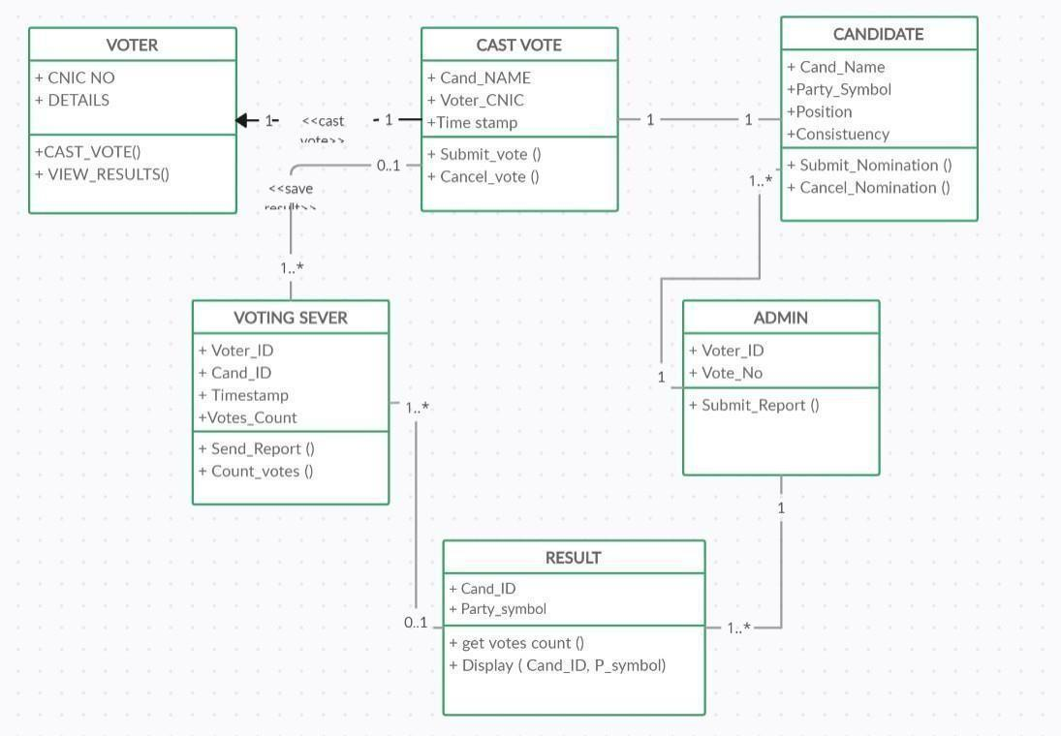

*Figure 14: Class Diagram*

## Information Viewpoint:

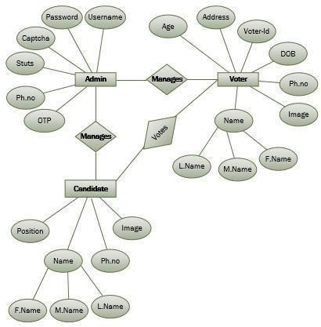

*Figure 15: ER Diagram*

## Interaction Viewpoint:

TO DO: Provide sequence diagrams for every use-case >>

## State Dynamics Viewpoint

<*The State Dynamic Viewpoint expresses the Dynamic state transformations of the system under study. The UML diagrams used to serve the purpose are UML State Machine Diagram, State Transition Table (Matrix).*

TO DO: UML State Machine Diagram>>

## Algorithmic Viewpoint

<*The detailed design description of operations (methods, functions), this applies to components, classes, and individual methods as design entities. The UML diagrams used to serve the purpose are Decision Table, Pseudo Code.*

TO DO: Provide Decision Table or Pseudo Code for the complete software>>

*Figure 16 : Sequence Diagram*

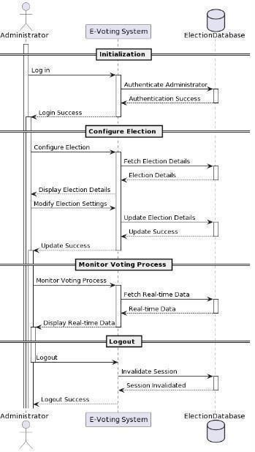

*Figure 17: Sequence Diagram*

## 3.6 State Dynamics Viewpoint:

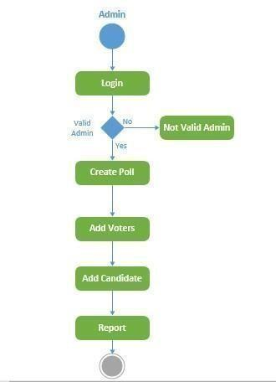

*Figure 18: Admin State Diagram*

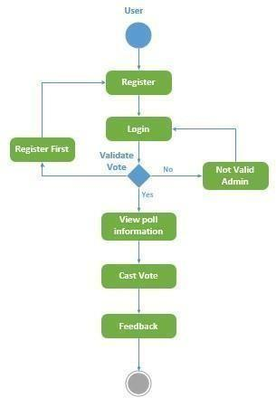

*Figure 19: User State Diagram*

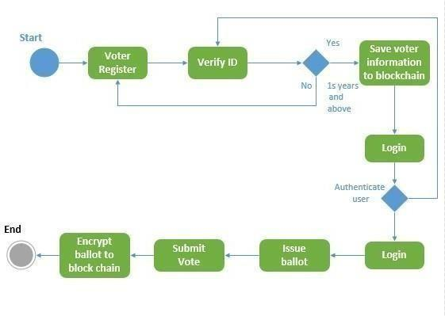

*Figure 20: Voter State Diagram*

# DEVELOPMENT AND TOOLS

This chapter is the authors’ discussion of development and tools used in implementing the “Android Based E-Voting System”. It provides some details of the team, the proposal so formulated for development and how work is divided among the members.

## Define

In this chapter, we propose a development plan for the ” Android Based E-voting system project ” tools employed in the process and future development of the project. We talk about team regulars of the project, and the development plan which has activities/workload allocation as well as the tools/IDE that was used during development. Beyond that we pause briefly by providing some tips on what could have been done next time or in the future so that this project may was more’ featured or covered.

## Development Plan

This project is developed by a team of two members.

1. Muhammad Nadeem
2. Muhammad Usman

**Gant Chat/Table**



*Figure 21: Gant Chart*

## Development Tools

To create the “Online Web Based Examination Portal” project, we used the following tools and IDEs:The following tools and IDEs were employed in the development of the “Online Web Based Examination Portal” project:

**Programming Languages:**

**Dart:**It is described to be used in the frontend part of the application.

**Frameworks:**

**Flutter:** Engaged exclusively for the frontend user interface design.

**Database Management System:**

**Firebase:** Selected for the storage and retrieval of data in the company because of its effectiveness in data relativity.

**Version Control:**

**Git:** For the different versions and for the people who work in pair or in a small team.

Integrated Development Environments (IDEs):

**Visual Studio Code:** Used as the main Integrated Development Environment for code writing and bug detection.

**Android Studio:** It is employed in developing Flutter applications to be run on Android and also during the testing process.

## Conclusion and Future Work/Extensions

The adopted e-voting system based on the Android has demonstrated the ability to develop a safe structure that is easy to navigate for the users during democratic elections. We can make it better by integrating with government databases to try and make the voter registration process easier to navigate, and using blockchain for a more secure voting process, votes recorded on blockchain can then be made available for public viewing to prevent tampering by adding transparency enhancement added by employing machine learning which inherently understands the behavior of the voters even better. These will improve its propriety and increase the usability which are among the key concerns put forward by today’s democracy.

# QUALITY ASSURANCE

This chapter develops about quality assurance of the “Android Based E-Voting system ” project in terms of reliability, accuracy and usability of the application. It highlights testing strategies,

methods that are used in establishing the effectiveness and efficiency of the functions of the system. Every segment under QA is carefully examined so as to deduce the potential difficulties that might be encountered hence guaranteeing smooth user experience in terms of functional testing all the way to performance and security testing.

## Define

This particular chapter outlines Quality assurance phase in Test Plan under the heading of “Android Based E-Voting system” Different categories of testing techniques used in order to make the application more reliable and accurate hence providing a perfect interface to the users without flaws. The requirement traceability matrix was created against each test case vis a vis the desired functional requirements that a system should posses; this considered broad test coverage given the fact that satisfaction of the user remains their main goal here.

## Traceability Matrix

**Table : 1**

| **Test Case ID** | **Requirement** | **Admin** | **Voting** | **Reports** | **Real-time Updates** | **Data Management** |
| --- | --- | --- | --- | --- | --- | --- |
| TC001_Admin | Admin Login with facial recognition |  | |  |  |  |
| TC002_Voting | Add Voters Data |  |  |  |  |  |
| TC003_Reports | Edit/Delete Candidates’ Particulars |  | | ⎫ |  |  |
| TC004_Reports | Create a Poll/Election |  |  | ⎫ |  |  |
| TC005_Data Management | Provide a database having voters’ information |  | |  |  | ⎫ |
| TC006_Data Management | Edit/Delete voter’s information in the database |  |  |  |  | ⎫ |

| TC007_Reports | Provide database having the total number of casted votes |  |  | ⎫ |  |  |
| --- | --- | --- | --- | --- | --- | --- |
| TC008_Reports | Produce a report or analysis based on the total casted votes and voting ratio statistically in a graphical view  Produce detailed report demographically and based on the male/female voting ratio  Connect to the system through the Android application |  |  |  |  | ⎫ |
| TC009_Reports |  |  |  |  |  |
| TC010_Reports |  |  |  |  | ⎫ |
| TC011_Voting | Sign up for cast vote |  |  |  |  |  |
|  | Login for voting with facial |  |  |  |  |  |
|  |
| TC012_Voting | recognition authentication |  |
|  | Cast a vote in favor of a |  |  |  |  |  |
| TC013_Voting | candidate/subject |  |
| TC014_Reports | View results after polling time |  |  |  |  |  |
| TC015_Reports | Produce a report on total casted votes and voting ratio |  |  |  |  |  |

## Test Plan

**Table : 2**

| **Test Case ID** | **Test Objective** | **Steps** | **Expected Result** | **Actual Result** | **Pass/Fail** | **Requirement** |
| --- | --- | --- | --- | --- | --- | --- |
| TC001 | Admin Login with facial recognition | 1. Open the  admin login page. | Admin login page is displayed. | Admin face is recognized, and access is granted. | Pass | Authentication and  Access Control |
| TC002 | Add Voters Data | 1. Access the "Add Voters" section. | Add Voters form is displayed. | Voter informationis added to the database. | Pass | Voter Management |
| TC003 | Edit/delete candidates’ particulars | 1. Navigate to the candidates list. | Candidates list is displayed. | Edit/delete options are available for selected candidate. | Pass | Candidate Management |
| TC004 | Create a  poll/election | 1. Access the "Create Poll/Election" section. | Poll/Election creation form is displayed. | Poll/Election is successfully created. | Pass | Election Management |
| TC005 | Provide a  database having voters’ information | Ensure the database  is accessible. | Database containing voters’ information  is available. | Database  is accessible. | Pass | Data Availability |
| TC006 | Edit/delete voter’s information in the database | Access  voter database. | Options to edit/delete voter information are available. | Voter informationis successfully edited/deleted. | Pass | Voter Management |
| TC007 | Provide database having the total number of casted votes | Access voting database. | Database containing total number of casted votes is available. | Database  is accessible. | Pass | Data Availability |

| TC00 9 | Produce detailed report demographically and based on the male/female voting ratio | Generate demographic voting report. | Report detailing male/female voting ratio is generated. | Report  is generated with male/female voting ratio. | Pass | Reporting Analysis | and |
| --- | --- | --- | --- | --- | --- | --- | --- |
| TC010 | Connect to the system through the Android application | Open  the Android app. | Login screen of the voter module is displayed. | Login screen is displayed. | Pass | System Accessibility | |
| TC011 | Sign up for cast vote | 1. Access the sign-up page. | Sign-up page is displayed. | Voter account is created successfully. | Pass | Voter Management | |
| TC012 | Login for voting with facial recognition authentication | Access  the login page. | Login page is displayed. | Voter face is recognized, and access is granted. | Pass | Authentication and  Access Control | |
| TC013 | Cast a vote in favor of a candidate/subject | 1. Access the voting section. | List of  candidates/subjects is displayed. | Vote is cast successfully. | Pass | Voting Process | |
| TC014 | View results after polling time | 1. Access the "View Results" section. | Results page is displayed. | Results of the election are shown. | Pass | Reporting Analysis | and |
| TC015 | Produce a report on total casted votes and voting ratio | Generate voting report. | Report with total casted votes and voting ratio is produced. | Report is generated with expected data. | Pass | Reporting Analysis | and |

# USER MANUAL

This chapter is a user guide to the application “Android Based E-Voting System.” It has an introduction that gives an account of why this manuel was prepared, System hardware and software characteristics, installation procedure, and operational manuel which offers step by step guidelines on how to use the various features in the application.

## Introduction

This part therefore provides the reader with an expectation of what is expected from an understanding of this document by explaining the purpose and format of this document. It also works as a prior alert on what is contained in the book, hence serves as a backdrop to other chapters that may follow.

## Hardware/Software Requirements for the System

**User Devices:** Smartphones.

**Server Hardware:** First, enough processing power, memory/ram & disk/storage space.

**Database Management Systems (DBMS):** Relational databases such as Firebase.

**Operating Systems:** Windows 10 or later versions; macOS 10.12 or later versions; Linux distributions.

## Installation guide for Application

Get the application from the foregoing source as and when applicable.

Begin the setup wizard mode and then follow the instructions that are given on the screen as they are.

The changes that may be made during the configuration stage are on the several options and parameters of the app. Finish the installation of the application before you see opening the application afterwards.

## Operating Manual

As a participant, one has to enter correct login details so as to get logged in to the e-voting application.

The following are some of the sections which are displayed on the screen as explained above while exercising your ballot during the polls process do not neglect to use some of the features as listed; veriy your identity using the biometric authentication, these are just choose your preference and cast it before the set time lapses, there is a section of the profile whereby you can edit your details and also setting if needed.